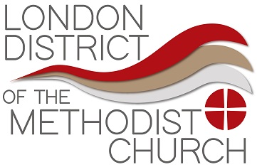
Request for Warm Welcome funding support

Note and guidance to applicants:
- This is short term funding for Churches across London.
- Requests for each Church in need of funding should be submitted as a Circuit wherever possible to the District Office (via admin@methodistlondon.org.uk).
- Requests for funding should support current Church initiatives offering a warm space (those already noted on the District website’s support map on the Cost of Living page will provide the indicator to current initiatives – if you have not submitted your initiative, please send details of this to the team immediately).
- Please ensure that you have completed a safeguarding risk assessment for your initiative.
- £1k is the recommended figure for each Church.
- It is expected that this fund will be accessed by Circuits and Churches in particular financial need. The total fund amount agreed by the District Advance Fund may be topped up if deemed necessary.
- Requests for funding will be reviewed on a rolling basis by the District Chairs, the District Property Development Officer and DAF Secretary.
- This support fund is restricted to warm space/warm welcome initiatives only and must not be used for any other projects within the Church. There are other funding opportunities for other projects and these should be made via DAF as usual. The fund cannot be used to support Circuit Assessment payments.
- Requests should be sent directly to the District Team via admin@methodistlondon.org.uk and a member of the team will confirm receipt and initiate the start of your funding request. Please do not copy any of the approvals panel into your initial submission as this causes confusion and delay in processing the correct copy of your request. If the approvals panel have a query, they or a District Team member will come back to you.

About the Request |  | For Office Use:
Circuit Name: |  | Circuit Number:
Name of Church (s):
Superintendent Name:
About the funding support (Note it is not to be used to pay Circuit Assessment)
What is the total amount you are applying for (please state amounts against each Church you are applying for if different)?
Payment details - Bank/ CFB account details (if funding is approved)
Account Name:

Account Number: |  | *Sort code:
Bank Name: |  | (* Sort Code not necessary for CFB payments)
Note: all payments will be made by BACs unless the District are instructed otherwise.
 | Tick here to confirm that a Safeguarding Risk Assessment has been completed for the Warm welcome/space initiative

Description: Please give a brief description (no more than 500 words) of the project for which you are seeking funding support. This description should fully expand on how the funding will be spent, including appropriate costings where applicable.

Signed:
(Superintendent Minister)

Date:

For office use only
Approvals

Amount approved – if not the full amount requested please give reason
Approvals need to be signed and dated by 2 of the following officers
Please print name | Signature | Date
1…………………………………………..
District Chair
2…………………………………………..
DAF Secretary
3………………………………………
District Property Development Officer

