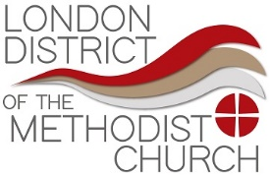

Request 3Generate Grant

The District will provide a grant of up to £55 per young person attending 3Generate 2024.

Applications are to be submitted via the District Office ([admin@methodistlondon.org.uk](mailto:admin@methodistlondon.org.uk)). We request that applications are made on a Church or Circuit basis.

Booking confirmation & receipts **MUST** be attached to the application.

**PLEASE NOTE THAT ALL CLAIMS MUST BE MADE BY FRIDAY 01 NOVEMBER 2024.**

|  |  |
| --- | --- |
| **About the Request** | **For Office Use:** |
| Circuit Name: | Circuit Number: |
| Name of Church (where applicable): | |
| Lay Leader/Minister Name: | |
| Address: | |
| Telephone: | email: |
| How many young people are attending? Please list in the table below | |
| **Payment details - Bank/ CFB account details** (if funding is approved)  Account Name: | |
| Account Number: | *Sort code: |
| Bank Name: | (* Sort Code not necessary for CFB payments) |
| *Note: all payments will be made by BACs.* | |

List Names of Young People attending

|  |  |
| --- | --- |
|  |  |
|  |  |
|  |  |
|  |  |
|  |  |
|  |  |
|  |  |
|  |  |
|  |  |

Signature ____________________ Date

For office use only  
Approvals

Total Amount approved ______________________________

Approvals

|  |  |  |
| --- | --- | --- |
|  | Signature | Date |
| District Chair |  |  |